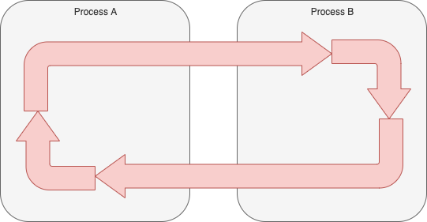
Fig. <$n:figure:UnnaturalLoop> Unnatural Loop

Looping does not naturally fit the notions of distributed programming.

Running one loop across several processors is possible but requires extra programming work and implementation details.

Force-fitting an unnatural construct onto a paradigm usually results in accidental complexities.

